**Lab 12**

**Name :-** Aryan Dilipbhai Langhanoja

**Date :-** 29-08-2023

**Enrollment No :-** 92200133030

**CO1: To write, test, and debug simple Python programs**

**CO2: To implement Python programs with conditional, loops and functions**

**Task 1:- Reading Files Using Numpy**

**Python Code:**

File = np.loadtxt("Matrix.txt",dtype=int)

print(File)

**Output:**

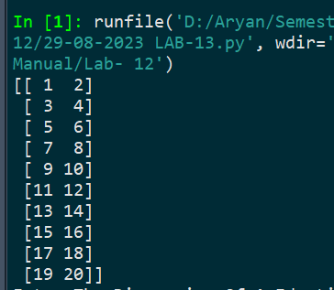

**Task 2:- Reading Files Using Numpy**

**Python Code:**

F2 = np.loadtxt("Name.txt",skiprows=1,dtype=str)

print(F2)

**Output:**

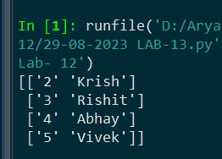

**Task 3:- Reading Files Using Numpy**

**Python Code:**

F3 = np.loadtxt("Marks.txt",dtype=str,usecols=2,skiprows=1)

print(F3)

**Output:**

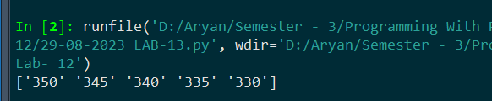

**Task 4:-** **Reading Files Using Numpy**

**Python Code:**

F4 = np.genfromtxt("Alphabet.txt",dtype=str,encoding = None,delimiter = ',')

print(F4)

**Output:**

